IE2110 Operational Research l - Term Paper (AY2122 Semester 1)

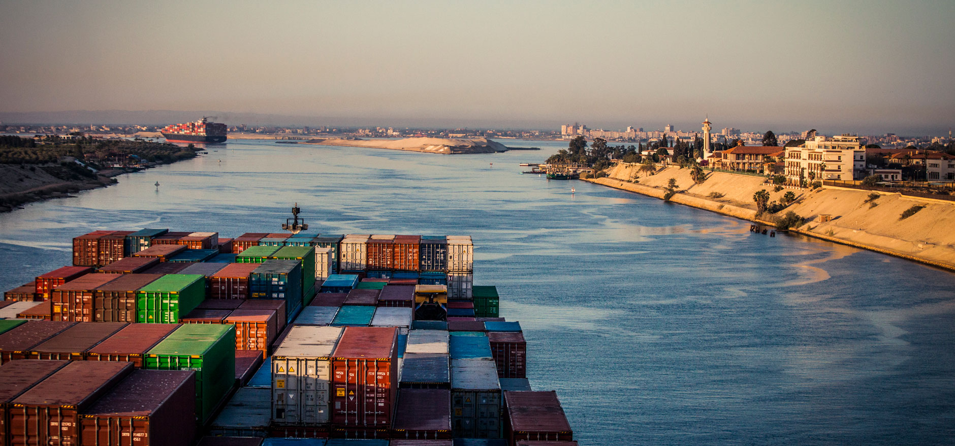

**Capacitated Plant Location Model**

**Group Members:**

Linn Htet Aung (A0220705U)

Liu Wei (A0223137N)

Loke Hong Yit Matthew (A0214955Y)

Quek Yong Jun (A0217017N)

Yukihide Takahashi (A0217265E)

**Supervising Professor:**

Associate Professor Ng Kien Ming

1. Introduction 3

1.1 Background & Motivation 3

1.2 Problem Statement 4

1.3 Methodology 5

2. Defining the Problem 6

2.1 Assumptions 6

2.2 Cost Matrices 6

2.2.1 Transportation Cost Matrix 6

2.2.2 Production Cost Matrix 9

2.2.3 Fixed Cost Matrix 10

2.2 Decision Variables 10

2.3 Objective Function 11

3. Result & Analysis 13

3.1 Initial Result 13

3.2 Analyzing Shadow Price 14

3.3 Varying the cost matrices according to scenarios 15

3.3.1 Suez Canal Blockage (Long Term) (Case 1) 15

3.3.2 Suez Canal Blockage (Short term) (Case 2) 17

3.3.2 Disrupted operations within certain regions due to natural disasters, strikes, pandemics, and other environmental/socio-political reasons. 19

4. Further areas of improvement 20

5. Conclusion 21

6. References 22

7. Appendix A: Examples of obtaining sea route distances using route planner 23

8. Appendix B: Solution for $yis$ for base model, case 1 and case 2 respectively 25

9. Appendix C: Shadow price for base model 26

10. Appendix D: Result for $xijs$ for case 1 27

11. Appendix E: Result for $xijs$ for case 2 28

# 1. Introduction

## 1.1 Background & Motivation

On 23rd March 2021, the Evergreen was passing through the Suez Canal northwards on its way to Rotterdam, Netherlands from China when it ran ashore. The ship’s 400m long and 59m wide-body effectively blocked the path of other vessels crossing the canal [1].

With about 12% of annual global trade passing through the Suez Canal (Nearly 19000 ships passed through the canal in 2020, making that 51.5 ships per day), the 6-day blockage inflicted great losses on several trading companies; some sources state that it held up trade value at over USD$9 billion per day, which equates to $400 million per hour or USD$6.7 million per minute [2].

Although such a case can be deemed unpredictable, i.e., a black swan situation, it is still crucial for companies to ensure the continuity of operations and prepare contingency methods to recalculate the shipping routes and find the cost-optimal route.

This project attempts to build such a model. We will first introduce a general model of maritime transportation, afterwards simulate various scenarios that would disrupt global trade, and finally analyze how companies in the various regions should react. A simulation including such extreme conditions provides insight to management that allows for formulating concrete contingency plans and results in better risk management.

## 1.2 Problem Statement

We shall formulate the problem as a Linear Programming (LP) Optimization Problem that is broken down into two phases; Phase I would be the pathfinding phase while Phase II would be the allocation phase. Our model involves 10 countries representing the regions: the United States of America (North America), Netherlands (Scandinavia), Brazil (South America), Belgium (Europe), Ukraine (East Europe), China (Asia), United Arab Emirates (Middle East), South Africa (Africa), Australia (Oceania), Singapore (Southeast Asia). These regions will act as both a supply point and a demand point. We will begin our construction of our model by first determining the shortest path between regions in Phase I.

Then, in Phase II we shall allocate production to various regions to minimize the costs associated with production and transportation of goods. To make the model realistic, we will introduce two types of factories, namely high-capacity and low-capacity, that both produce an arbitrary generic product. Each region is assumed to operate either a factory with high-capacity or with low-capacity or both types or neither. Phase II will consist of determining the type of factories to be open for production within the region and the quantity produced and shipped to demand points. For this LP, the demand and supply of the regions are assumed to be on a yearly basis.

## 1.3 Methodology

This project will utilize PuLP, a python package that provides utility functions for Linear Optimization problems. Various information characterizing the problem such as the production cost matrix, fixed cost matrix, the supply matrix, and the demand matrix will be inserted as Pandas DataFrames. These will be utilized to build our objective function and constraints.

As for the transportation cost matrix, we shall utilize information using a satellite map. We will develop a matrix that describes the sea route distance from each region to every other region. Thereafter, we will utilize Dijkstra's algorithm to find the shortest path from each region to the other demand points. All the above processes shall be further elaborated individually in the subsequent sections.

Lastly, the Python code will be written and run on Jupyter Notebook; the final code is in the file named “Capacitated_Plant_Location_Model.ipynb” with multiple CSV files containing data used in our model.

# 2. Defining the Problem

## 2.1 Assumptions

The list below summarizes the various assumptions that were made in building the model.

* The cost of transportation is proportional to the distance between regions.
* The cost of transportation and production are the only factors that determine the allocation of production.
* Each sea route has an infinite capacity (no restriction on the number of vessels that can pass through).
* Capacity for low and high cap factory is fixed at 500,000 and 1,500,000 unit respectively

## 2.2 Cost Matrices

This model features three cost matrices: namely the Transportation Cost Matrix, the Production Cost Matrix, and the Fixed Cost Matrix.

### 2.2.1 Transportation Cost Matrix

The transportation cost matrix consists of the cost to transport a product between each demand and supply point. This matrix reflects the realistic strategy to transport products via the cheapest route where possible. Thus, we shall utilize Dijkstra’s algorithm, which is able to find the shortest (cheapest due to proportionality assumption) path from a node to any other node on a graph with only non-negative weighted edges.

To obtain the transportation cost matrix, we first create a base network model consisting of the different regions (nodes) and the different connecting routes between the regions (edges). This is shown in Figure 1.

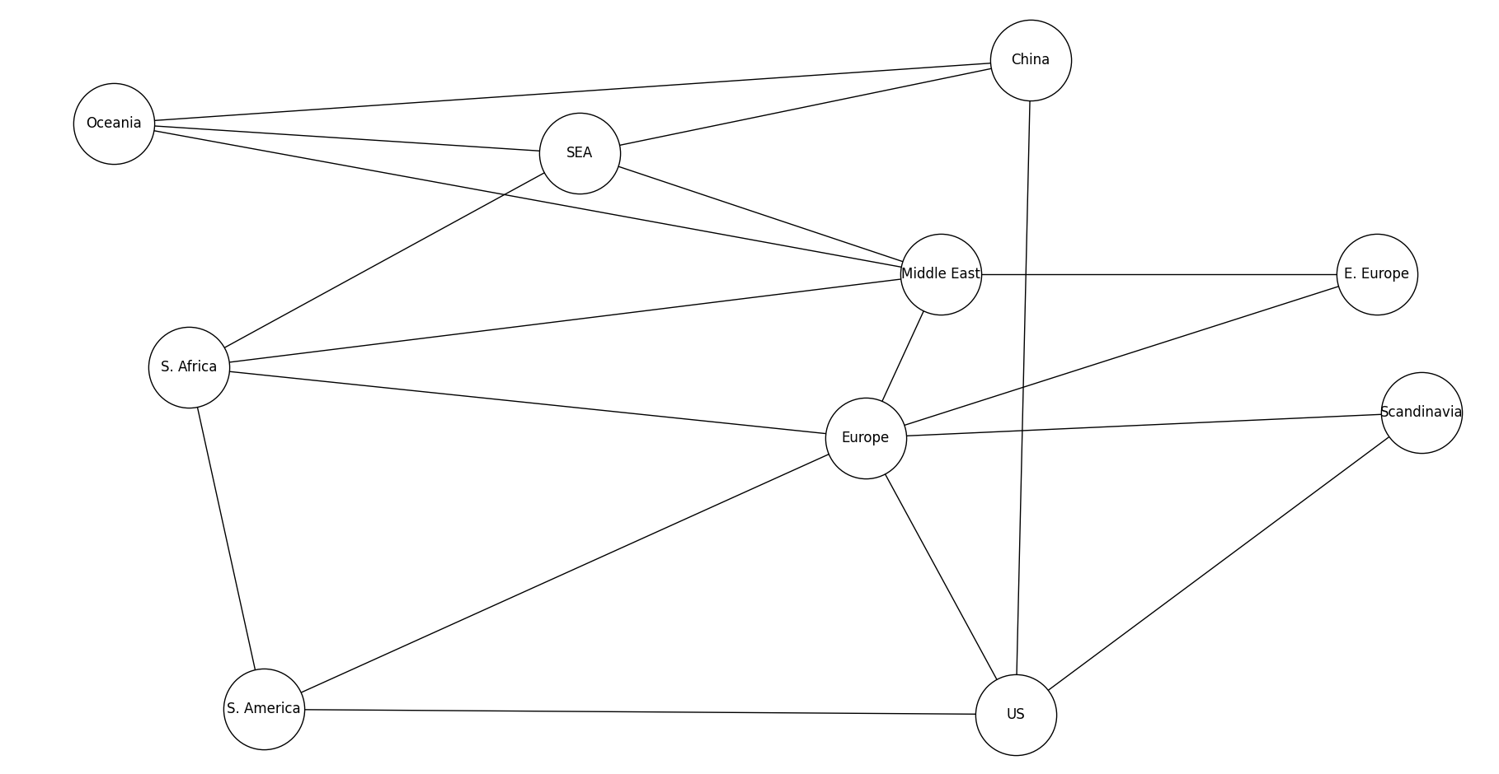

Figure 1. Base Network Model

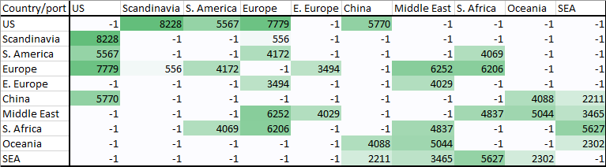

Table 1. Distances between different nodes (Nautical Miles)

After developing our Base Network Model, we generated Table 1 by finding the distances of the connecting routes between each of the nodes by referencing a website that contains information on distances of maritime trading routes [3].

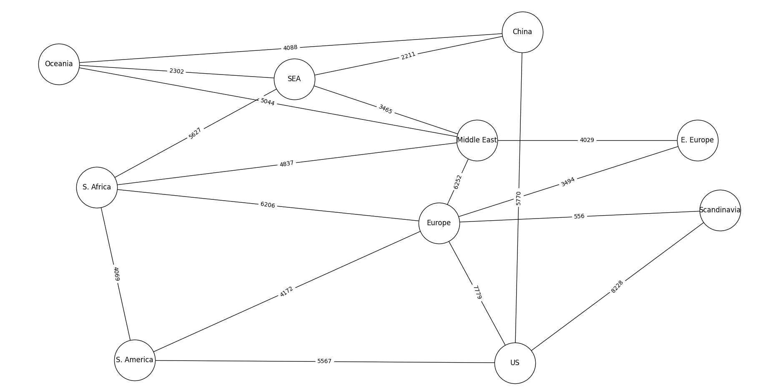

Figure 2. Base Network Model with distances between trading routes

Integrating data from Table 1 into the Base Network Model, we can generate the network model as shown in Figure 2. The network model allows us to use Dijkstra’s algorithm, which is used to obtain the shortest path from one region to another, shown in Table 2.

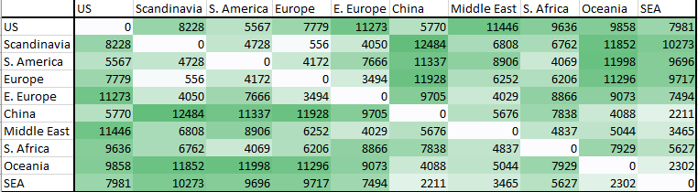

Table 2. Summary of the shortest paths between each region (Nautical Miles)

Using Table 2, we can summarize the cost of shipment between any 2 regions to generate Table 3 as shown below. The cost is generated by scaling the distance between regions by a factor of 1/1000. Due to the lack of data available, we use a rough heuristic to estimate the unit transport cost.

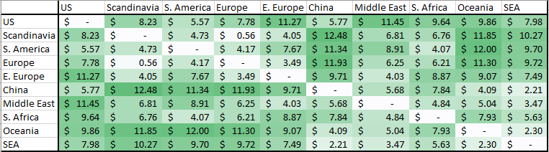

Table 3. Transportation Cost Matrix between regions

### 2.2.2 Production Cost Matrix

For the unit production cost, we have the table below (Table 4) which summarizes the cost of producing one unit of goods in a certain region of a certain plant capacity.

Table 4. The unit cost of production for each type of factory in each region

The unit production cost was estimated to be 1 order of magnitude more than the transport cost [4]. In addition, the group took reference from the mean salary of each region [5], thereafter scaling them to develop the production costs for the low-capacity factory and the high-capacity factory (0.9 of Low-capacity) respectively. In doing so, we can maintain the comparative differences in unit production costs we expect to see in the real world. (e.g. High production cost in high labor costs regions)

### 2.2.3 Fixed Cost Matrix

Table 5 describes the fixed costs for each type of factory in each region. Fixed costs are capital investment in equipment and maintenance required to start production. For example, it would take 65 million dollars to set up a low-capacity factory in the United States. Due to the lack of data available, the fixed cost is roughly estimated by using heuristics.

Table 5. The fixed cost for Low-Capacity/ High-Capacity factories

## 2.2 Decision Variables

Our set of decision variables comprises both continuous and discrete variables. The continuous variable refers to the amount of product that is produced by each factory type in each region. The discrete (binary) variable will express whether a certain factory type in a certain region is being used. When the discrete variable is 1, the fixed cost will be added to the objective function, and when the discrete variable is 0, no fixed cost will be added to the objective function. In the latter case, no products can be manufactured at this factory.

Decision Variables

$$x_{ijs}=Quantity produced in factory of size s in region i and shipped to region j$$

$$y_{is}=1 if the plant at region i of size s is open and 0 if closed$$

There are a total of 220 decision variables. 20 will be binary variables (whether to utilize a certain factory in a certain region; 2 factories * 10 regions = 20), while the remaining 200 will be continuous (how much a certain factory in a certain region produces and ships to a destination (2 factories * 10 supply points * 10 demand points = 200).

## 2.3 Objective Function

Our objective function for cost optimization is as follows:

$$Minimize z=\sum_{i=1}^{n}{\sum_{j=1}^{n}{\sum_{s=0}^{1}{{(t}_{ij}+p_{is})x_{ijs}}}}+\sum_{i=1}^{n}{\sum_{s=0}^{1}{f_{is}y_{is}}}$$

$$t_{ij}=transport cost from region i to region j$$

$$p_{is}=production cost of factory of size s in region i$$

$$f_{is}=fixed cost of keeping factory of size s in region i open$$

$$n=number of regions$$

$$s=low or high capacity plant (0 or 1)$$

The objective function is a linear combination of the continuous and discrete decision variables, represented by $x_{ijs}$ and $y_{is}$, multiplied by its respective costs. The model consists of three types of costs, the transportation cost $t_{ij}$, production cost $p_{is}$ and fixed cost $f_{is}$. The first term in the linear combination $\sum_{i=1}^{n}{\sum_{j=1}^{n}{\sum_{s=0}^{1}{{(t}_{ij}+p_{is})x_{ijs}}}}$ represents the overall variable cost of transportation and production for each factory type in each region while the latter term $\sum_{i=1}^{n}{\sum_{s=1}^{1}{f_{is}y_{is}}}$ represents the cost of utilizing factories in certain regions (Fixed costs).

2.4 Constraints

Our constraints are that (1) we will have to meet the demand in each region while (2) conforming to the supply limits in each factory type in each region.

Demand Constraint

$$\sum_{i=1}^{n}{\sum_{s=0}^{1}{x_{ijs}}}=D_{j}∀j$$

$$D_{j}=Demand at region j$$

Capacity Constraint

$$\sum_{j=1}^{n}{x_{ijs}}≤ k_{is}×y_{is}∀\left(i,s\right)$$

$$k_{is}=Capacity of plant of size s in region i$$

In addition, all decision variables shall be non-negative.

The demand and supply at each region are set as follows:

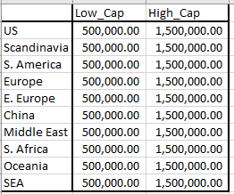

Table 6. Demand for each region

Table 7. Supply for each region

# 3. Result & Analysis

## 3.1 Initial Result

The 2 tables below (Table 8) describe the results we obtained after the first run. This first run is the controlled scenario where all the trading routes are available, and all factories can be utilized. For subsequent scenarios, the result tables will be attached in the appendix due to lack of space.

Table 8. Production of factories for different regions and where the product is supplied to and from (solution for $x_{ijs}$)

From Table 8, each cell is represented by the variable $x_{ijs}$ where i is represented by the region vertical column and s represents the specific type of factory in that region. j is represented by the horizontal row of the region the product is being shipped to. This table allows us to calculate the cost which is $284,016,804.08. Refer to appendix B for solutions for .

Table 9. Cost Breakdown for Base Model

## 3.2 Analyzing Shadow Price

The table below provides insights regarding the shadow price for each constraint.





Table 10. Shadow price for selected constraints (Refer to Appendix C for full table)

Based on Table 10, we can estimate the minimum price of goods to make a profit. For example, if the demand for the US increases by 1, the cost will increase by $22.03. This means that to make a profit, the product sold in the US must be charged higher than $22.03. We are also able to see the amount of cost reduction that can be achieved by increasing the capacity of the factory. For example, increasing 1 unit of capacity for China High-capacity plant will lead to the most decrease in costs ($10.96).

Interestingly, US Low Cap have 0 slack but 0 shadow price. This is likely due to $y_{US,LowCap}=0$ (Refer to appendix B),

$$\sum_{j=1}^{n}{x_{ijs}}≤ k_{is}×y_{is},where i is US,s is low Cap$$

The RHS constraint is 0. Hence slack is 0 since the factory is not open for production.

## 3.3 Varying the cost matrices according to scenarios

The scenarios that follow simulate situations where transportation/production is disrupted. In each of them, we will modify the cost matrix accordingly and perform LP optimization.

### 3.3.1 Suez Canal Blockage (Long Term) (Case 1)

With the Suez Canal Blockage, the 2 trading routes (Middle East $→$ East Europe, Middle East $→$ Europe) will be unavailable. This is shown in the network model below (Figure 3).

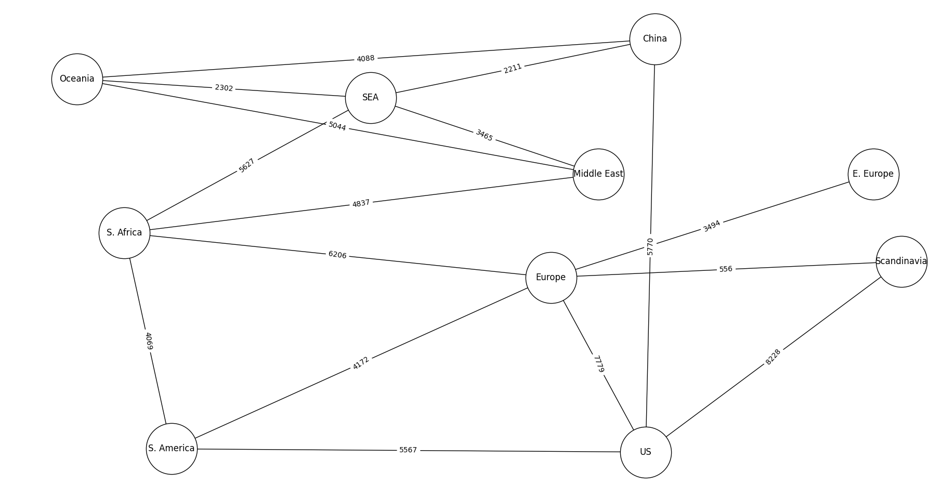

Figure 3. Network Model with Suez Canal Blockage

Using this new network model, we can generate the new transport cost matrix as shown in the table below.

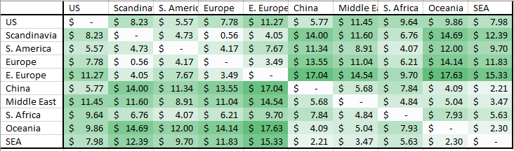

Table 11. New Transportation Cost Matrix between regions (Suez Canal Blockage)

We are also able to determine the difference in the transportation cost between the control scenario and the Suez Canal Blockage scenario. This is shown in Table 12 below.

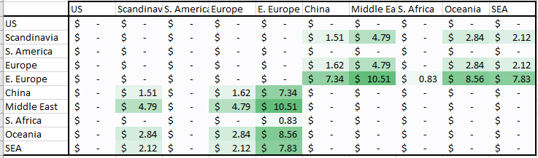

Table 12. The difference in transportation cost from the control scenario

With the new transportation cost matrix, we can determine the results for the Suez Canal Blockage. The full result for $x_{ijs}$ is in appendix D and result for $y_{is}$ in Appendix B.

We calculate the new cost for the to be $287,193,261.58. We observe an increase in the objective value of $3,176,457.5. Below is a table to describe the breakdown of the cost. As seen in table 14, transport cost increased by $3,026,457.50 due to the Suez Canal Blockage as overall transport cost in the network become more expensive as seen in Table 12.

Table 13. Cost Breakdown for Case 1

Table 14. Cost Difference (Case 1 – Base Model)

### 3.3.2 Suez Canal Blockage (Short term) (Case 2)

In the earlier scenario (Suez Canal Blockage Case 1), the decision maker is allowed to uproot their factories and set up elsewhere when there are disruptions in supply chain. However, companies will not be able to react quickly enough to black swan events like the Suez Canal Blockage. Thus, we will next model the case when companies are forced (in the short run) to continue using the factories that were already built in regions that are based on the conditions of the control case where there are no supply chain disruptions. To model this, we must add additional constraints on $y_{is}$, whereby it is set to 1 for factories where it was decided to be open based on the control case.

Table 15. Cost Breakdown for Case 2

Table 16. Cost Difference (Case 2-Base Model)

Table 17. Cost Difference (Case 2-Case 1)

The above table (Table 15) shows the new result with objective value of $288,965,761.58. Note that factories opened in the base case is also open in this scenario. The increase in cost from the base case ($284,016,804.08) is $4,948,957.5. As expected, transport cost increased since the unit transport cost of some edges in the network increased due to the Suez Canal Blockage. Notably, comparing case 1 and case 2, case 2 had a higher cost of $1,772,500.00. This shows it is costly to be slow in reacting to crisis like the Suez Canal Blockage. Additionally, by finding the difference in $y_{is}$ for case 1 and case 2, we can provide recommendation on which factory to open or close to avoid the extra cost of $1,772,500.00 per year. Recall that case 1 is where one is allowed sufficient time to close a factory and relocate elsewhere while case 2 only has factories opened under the assumption of normalcy (Base model) (In other words, $y_{is}$ of case 2 is constrained to be the solution of $y_{is}$ for the base model.). In this case, it is recommended to close a low cap factory in the Middle East and open a low cap factory in South Africa.

Table 18. Difference in solution for $y_{is}$ (Case 1-Case 2)

### 3.3.2 Disrupted operations within certain regions due to natural disasters, strikes, pandemics, and other environmental/socio-political reasons.

For these scenarios, we assume one of the regions is unable to produce any goods due to reasons such as natural disasters, strikes, pandemics, etc. This is done by adding 2 additional constraints which are to pre-assign the $y_{is}$ variable to 0 for region i.

Additional Constraint

$$\sum_{s=0}^{1}{y_{is}}=0, for region i$$

With these additional constraints, we can compute the increase in the minimum cost for different scenarios where each region experiences disruptions in production. This is shown in the table below (Table 19). From Table 19, China has the highest difference in minimum cost ($38,296,743.13) and this means that China will be affected the most if disruptions were to occur in China relative to the other regions.

Table 19. The difference in minimum cost for each scenario where a certain region faces disruptions in production

# 4. Further areas of improvement

One potential area of improvement of our model would be to consider the capacity of each sea route. In our network, we assumed that an infinite amount of traffic can pass through each of the routes. This is unrealistic, however; for example, canals such as the Suez Canal have limits to how many vessels can pass through at a unit amount of time.

Thus, to make the model more realistic, we could retrieve data describing the maximum allowable vessels through certain choke points, such as the Suez Canal or the Malacca Strait. In doing so, we can assign a capacity to each arc in our graph, thus adopting a more general form of a minimum-cost network flow problem.

One predicted outcome for this implementation is that in the case where the transportation on an edge reaches its full capacity but there is still demanded to be satisfied, some products will have to be allocated to other regions which may have higher transportation/production costs.

In addition, in formulating our various cost matrices and thereafter the objective function, we applied general heuristics on several occasions. This includes developing our transportation cost matrix by scaling each distance by a factor of 1/1000 and applying rough scaling to the mean salaries in each region to develop a production cost matrix. With the usage of more data, we shall be able to develop more accurate and realistic cost matrices.

Given more time and computing resources, we can increase the number of nodes and edges in the graph to better model real life conditions. The regions we considered are likely overly generalized, for example, USA is a large country, and we only use West cost to represent the whole region. This is one reason why the model indicates USA tends to import from China and Southeast Asia, since these regions are closer to the West Coast USA.

Finally, as our model analysis adopts an arbitrary, general product, we could expand this model to reflect realistic transportation of certain goods, including cars, rice, textiles, and computers. Again, this would require a collection of data that represents the various supply constraints and demand in each region.

# 5. Conclusion

This project has described a general model of maritime transportation and considered a few black swan situations where shipping routes must be recalculated due to inflated costs/factory availability.

In developing the cost matrix, the group implemented Dijkstra’s algorithm to find the optimal route from each supply point to each demand point. Thereafter the group formulated a Linear Optimization problem with an objective function to minimize and several constraints. As a result, we have achieved a good representation of the model. We have also provided useful insights using the simulated scenarios as well as the analysis of shadow price.

In the future, by introducing capacity to the edges in the network, we will be able to establish a more robust model.

# 6. References

[1] “Egypt's Suez Canal blocked by huge container ship,” BBC, 24 Mar 2021. [Online] Available: <https://www.bbc.com/news/world-middle-east-56505413> [Accessed 4 Nov 2021]

[2] Das, Koustav. “Explained: How much did Suez Canal blockage cost world trade,” India Today, 30 Mar 2021. [Online] Available: <https://www.indiatoday.in/business/story/explained-how-much-did-suez-canal-blockage-cost-world-trade-1785062-2021-03-30> [Accessed 4 Nov 2021]

[3] “VesselFinder”, VesselFinder, n.d. [Online] Available: <https://www.vesselfinder.com/> [Accessed 4 Nov 2021]

[4] “Freight Weights and Maritime Costs,” UNCTAD, October 2015. [Online] Available: <https://unctad.org/system/files/official-document/cimem7_rmt2015_ch3_en.pdf> [Accessed 7 Nov 2021]

[5] “Manufacturing Sector Average Salary - International Comparison,” WorldSalaries.org, 2007. [Online] Available: <http://www.worldsalaries.org/manufacturing.shtml> [Accessed 7 Nov 2021]

# 7. Appendix A: Examples of obtaining sea route distances using route planner

Route between Los Angeles and Goteborg

Route between Itaqui and Antwerpen

Route between Los Angeles and Shanghai

# 8. Appendix B: Solution for $y_{is}$ for base model, case 1 and case 2 respectively

Case 1

Base Model

Case 2

# 9. Appendix C: Shadow price for base model

# 10. Appendix D: Result for for case 1

# 11. Appendix E: Result for for case 2

